horizontal line

**Project namAir quality monitoring**

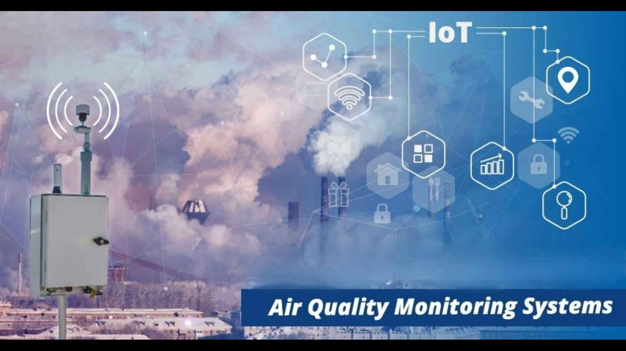

**Air quality monitoring development involves creating and improving systems and technologies to measure and assess the quality of the air in a specific location. This typically includes the following components:**

* **Sensor Technology: Developing or using advanced sensor technologies like laser-based particulate sensors, electrochemical gas sensors, or optical sensors to measure various air pollutants such as particulate matter (PM2.5 and PM10), nitrogen dioxide (NO2), sulfur dioxide (SO2), carbon monoxide (CO), ozone (O3), and volatile organic compounds (VOCs).**
* **Data Collection: Establishing data collection systems to gather information from the sensors. This can involve IoT devices, drones, satellites, or stationary monitoring stations.**
* **Data Processing: Developing algorithms and software for data processing, quality assurance, and real-time analysis to generate accurate air quality indices and pollutant concentration measurements.**
* **Communication: Implementing methods to transmit data to a central server or database. This may include cellular networks, Wi-Fi, or other wireless communication technologies.**
* **User Interface: Creating user-friendly interfaces, such as mobile apps or web platforms, to display air quality information to the public or relevant authorities.**
* **Data Visualization: Developing graphical representations and maps to present air quality data in an understandable and actionable way.**
* **Alerts and Warnings: Integrating alert systems that notify users when air quality reaches unhealthy levels, enabling them to take appropriate precautions.**
* **Integration with Environmental Policy: Collaborating with governmental and environmental organizations to ensure that collected data is used for policy-making and regulatory purposes.**
* **Calibration and Maintenance: Regularly calibrating and maintaining monitoring equipment to ensure the accuracy of air quality measurements.**
* **Purpose Research and Innovation: Continuously researching and innovating to improve the accuracy, reliability, and affordability of air quality monitoring technologies.**
* **Education and Outreach: Conducting awareness campaigns and educational programs to inform the public about air quality issues and the importance of monitoring.**

**Air quality monitoring development is crucial for addressing environmental and public health concerns, as it provides valuable data for understanding pollution levels, making informed decisions, and mitigating the impact of poor air quality.**

* **Air Quality Modeling: Utilizing advanced computational models to simulate and predict air quality patterns based on historical data and meteorological conditions. This helps in forecasting air quality and assessing the effectiveness of potential interventions.**
* **Mobile Monitoring Units: Developing mobile monitoring units that can be deployed to specific locations or events to assess air quality in real time. These units are especially useful for tracking air quality during emergencies or large gatherings.**
* **Remote Sensing: Leveraging remote sensing technologies like satellites and drones to collect air quality data on a regional or global scale. Remote sensing can provide a broader perspective on air quality trends and pollution sources.**
* **Big Data and Machine Learning: Harnessing big data and machine learning techniques to analyze vast datasets and identify patterns, trends, and correlations in air quality data. This can lead to more precise pollution source identification and targeted interventions.**
* **Sensor Miniaturization: Advancements in sensor miniaturization make it possible to integrate air quality sensors into wearable devices or even smartphones, allowing individuals to monitor the air quality in their immediate surroundings.**
* **Cross-Device Compatibility: Ensuring compatibility and interoperability among different monitoring devices and data sources to create a seamless network of air quality information.**
* **Air Quality Improvement Initiatives: Collaborating with governments and organizations to implement measures to improve air quality based on monitoring data, such as emissions controls, green infrastructure, and urban planning.**
* **Environmental Equity: Addressing disparities in air quality based on location and socioeconomic factors by prioritizing monitoring in vulnerable communities.**
* **Real-time Feedback and Reporting: Enabling users to report air quality issues and provide feedback, fostering community engagement and data validation.**

**Air quality monitoring is an evolving field that plays a critical role in environmental protection and public health. The continuous development and innovation in monitoring technologies help us better understand the state of the air we breathe and take steps to ensure cleaner and healthier environments.**

* **Mobile Apps and Wearables: The development of mobile apps and wearable devices equipped with air quality sensors provides individuals with real-time data on the air they are breathing. This empowers people to make informed decisions about outdoor activities and can contribute to personal health and well-being.**
* **Citizen Science Initiatives: Many air quality monitoring projects involve citizens who collect data through personal sensors or other means. These citizen science initiatives help expand the coverage of monitoring networks and engage local communities in addressing air quality issues.**
* **Cross-Border Collaboration: Air pollution often transcends national boundaries. Cross-border collaboration in air quality monitoring is crucial for addressing transboundary pollution and sharing data among neighboring regions to find collective solutions.**
* **Indoor Air Quality: Monitoring and improving indoor air quality has become increasingly important, especially given the amount of time people spend indoors. Technologies for monitoring indoor air quality include sensors for detecting VOCs, humidity, temperature, and particulate matter.**
* **Integration with Smart Cities: Air quality monitoring is a key component of smart city initiatives. Data collected can inform urban planning, traffic management, and energy consumption strategies to create more sustainable and livable urban environments.**
* **Environmental Sensors and IoT: The Internet of Things (IoT) is instrumental in the development of air quality monitoring systems. IoT devices can communicate seamlessly, making it possible to create a network of interconnected sensors and data points.**
* **Historical Data Analysis: Historical air quality data can provide valuable insights into long-term trends and the effectiveness of past interventions. Analyzing this data can inform future policy decisions and environmental planning.**
* **Real-time Feedback Loops: In some cases, air quality monitoring systems are integrated with other systems, like traffic management or heating and cooling systems, to create real-time feedback loops for reducing emissions and improving air quality.**
* **International Standards: The development of international standards for air quality monitoring equipment and data reporting ensures consistency and comparability of air quality data across regions and countries.**
* **Future Challenges: As air quality monitoring technology advances, new challenges emerge, such as cybersecurity concerns, data privacy issues, and ensuring that monitoring systems remain affordable and accessible for all communities.**

**The ongoing development of air quality monitoring systems is vital for addressing current and emerging environmental challenges, including climate change and public health concerns. It requires a multidisciplinary approach, involving technology, policy, and community engagement to create a cleaner and healthier future.**

**Developing software for air quality monitoring typically involves coding for data collection, processing, analysis, and visualization. Below is a simplified example of html code for a basic air quality monitoring system. Keep in mind that real-world applications can be far more complex and tailored to specific hardware and requirements:**

**html:**

**<!DOCTYPE html>**

**<html lang=”en”>**

**<head>**

**<meta charset=”UTF-8”>**

**<meta name=”viewport” content=”width=device-width, initial-scale=1.0”>**

**<title>Air Quality Monitoring Platform</title>**

**<style>**

**Body {**

**Font-family: Arial, sans-serif;**

**}**

**Header {**

**Background-color: #007ACC;**

**Color: #FFF;**

**Text-align: center;**

**Padding: 20px;**

**}**

**Main {**

**Padding: 20px;**

**}**

**#air-quality-data {**

**Border: 1px solid #ccc;**

**Padding: 20px;**

**Border-radius: 5px;**

**}**

**</style>**

**</head>**

**<body>**

**<header>**

**<h1>Real-time Air Quality Monitoring Platform</h1>**

**</header>**

**<main>**

**<div id=”air-quality-data”>**

**<!—Air quality data will be displayed here 🡪**

**</div>**

**</main>**

**<script>**

**// Simulated real-time data**

**Function generateRandomData() {**

**Return {**

**Pm25: (Math.random() * 100).toFixed(2), // Simulated PM2.5 level in µg/m³**

**Pm10: (Math.random() * 150).toFixed(2), // Simulated PM10 level in µg/m³**

**Co2: (Math.random() * 1000).toFixed(2) // Simulated CO2 level in ppm**

**};**

**}**

**Function updateData() {**

**Const airQualityDataElement = document.getElementById(‘air-quality-data’);**

**setInterval(() => {**

**const data = generateRandomData();**

**const timestamp = new Date().toLocaleTimeString();**

**// Update the data display**

**Const newData = `<p>${timestamp}: PM2.5: ${data.pm25} µg/m³, PM10: ${data.pm10} µg/m³, CO2: ${data.co2} ppm</p>`;**

**airQualityDataElement.innerHTML = newData + airQualityDataElement.innerHTML;**

**}, 3000); // Update data every 3 seconds**

**}**

**Window.addEventListener(‘load’, () => {**

**updateData();**

**});**

**</script>**

**</body>**

**</html>**

**Here's a breakdown of what this code does:**

* **Import necessary libraries: Import the libraries that handle sensor data, database operations, data analysis, and data visualization. You would need to create or use appropriate libraries for your specific sensors and requirements.**
* **Initialize sensors: Initialize the air quality sensor, temperature sensor, and humidity sensor. Replace this with actual code that initializes the sensors you have.**
* **Data collection loop: Continuously read data from the sensors in a loop.**
* **Read sensor data: Read air quality, temperature, and humidity data from the respective sensors.**
* **Store data in a database: Save the collected data to a database for further analysis and historical records. You would replace "database.save_data" with actual database-specific code.**
* **Analyze data for AQI: Calculate the Air Quality Index (AQI) based on the air quality data collected. The "analysis.calculate_aqi" function is a placeholder; you would need to create your own AQI calculation function.**
* **Visualize data: Update a dashboard or user interface to display the collected data and the calculated AQI. This visualization can help users understand the air quality in real-time.**